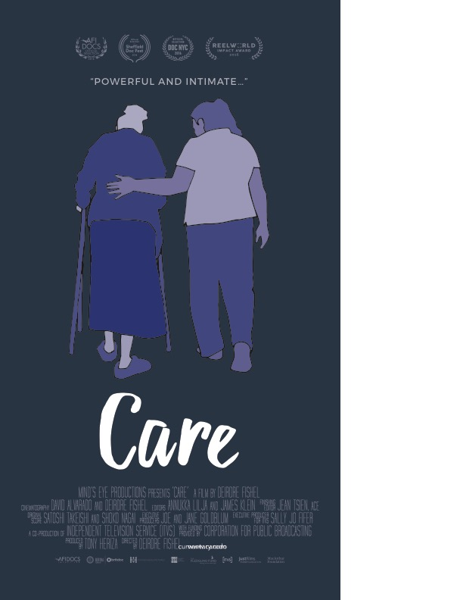
FI
FILM
SCREENING

Join us for a screening about the poignant world of in-home elder care, the bonds that form between paid care workers and elders, and the cracks in the US care system.

Panel discussion with caregivers to follow.

June 7, 2017
Amy’s Place
6:30 pm

14 Sloan St, Roswell, GA 30075

Contact Vanessa at 404-405-7704 with any questions.

Hosted by Caring Across Generations & Amy’s Place

